* Ridge Extraction:
  + A straightforward method is binarization.
  + • Problems:
    - – Sweat pores on ridges are brighter than the surrounding pixels;
    - – ridges can be broken due to cuts or creases;
    - – adjacent ridges may appear to be joined due to wet skin or large pressure.
  + • Countermeasure: fingerprint enhancement.
  + • General purpose image enhancement is not effective for fingerprint.
  + • A successful fingerprint enhancement method is contextual filtering, such as Gabor filtering.
* 2D Gabor Filters
  + 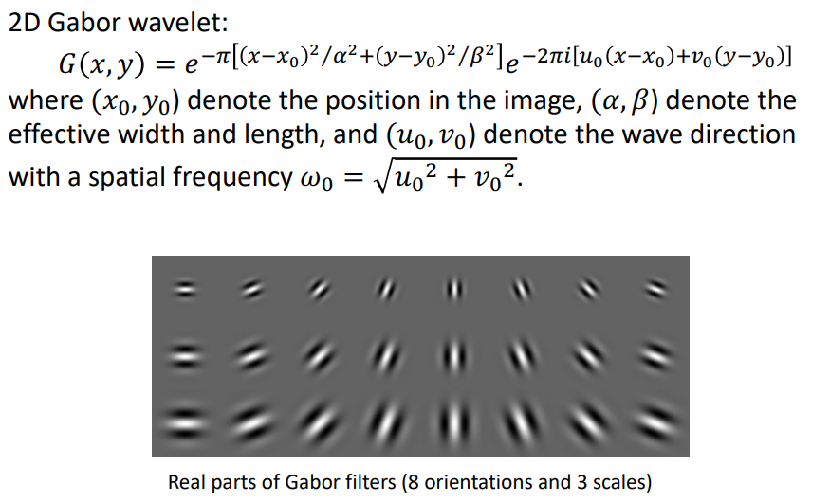
* Gabor filter can be defined by frequency and scale
* Ridge Extraction
  + Enhanced image can be converted into a binary image by comparing with thresholds (e.g. local mean).
  + • A morphological operation, thinning, is used to obtain the skeleton image.
  + • Thinning is a common technique in image processing, which involves iteratively removing outer ridge pixels.
* 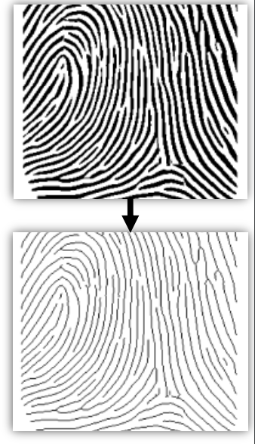
* Minutiae Extraction
  + Minutiae are special points on ridges: – ridge bifurcation (3 neighbors are black) – ridge ending (1 neighbor is black)
  + • Direction of a ridge ending: – Trace the associated ridge with a fixed distance (say 10 pixels) from ***x*** to ***a***. The direction ***xa*** is the minutia direction.
  + • Direction of a bifurcation: – Trace the ridges to get three directions. The direction is the mean of the two smallest different directions.
* 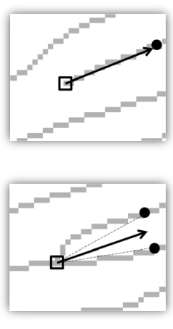
* MInutiae Verification
  + Previous method considers only 3×3 window, producing false minutiae due to:
    - – artifacts in image processing
    - – noise in a fingerprint
  + • A minutia is classified as false if it meets any of the following conditions:
    - – has no adjacent ridge on either side
    - – be close in location and opposite in direction
    - – too many minutiae in a small neighborhood

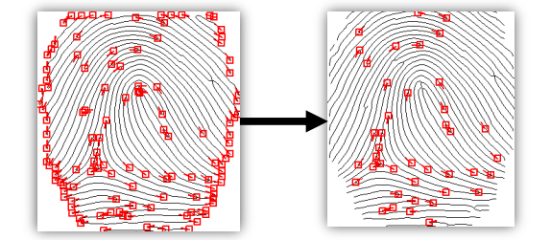

Front

Two profile(left/right)

Two pictures of eye close(left/right)